1. The example, shown in the following image below, shows the Superstore *Profit*measure, graphed from 2015 to 2018. It gives a ton of information about the Superstore's past, which allows you to hypothesize about the future. For example, it is likely that in 2019, *Profit* will continue to climb, and Q4 will be the most profitable quarter.

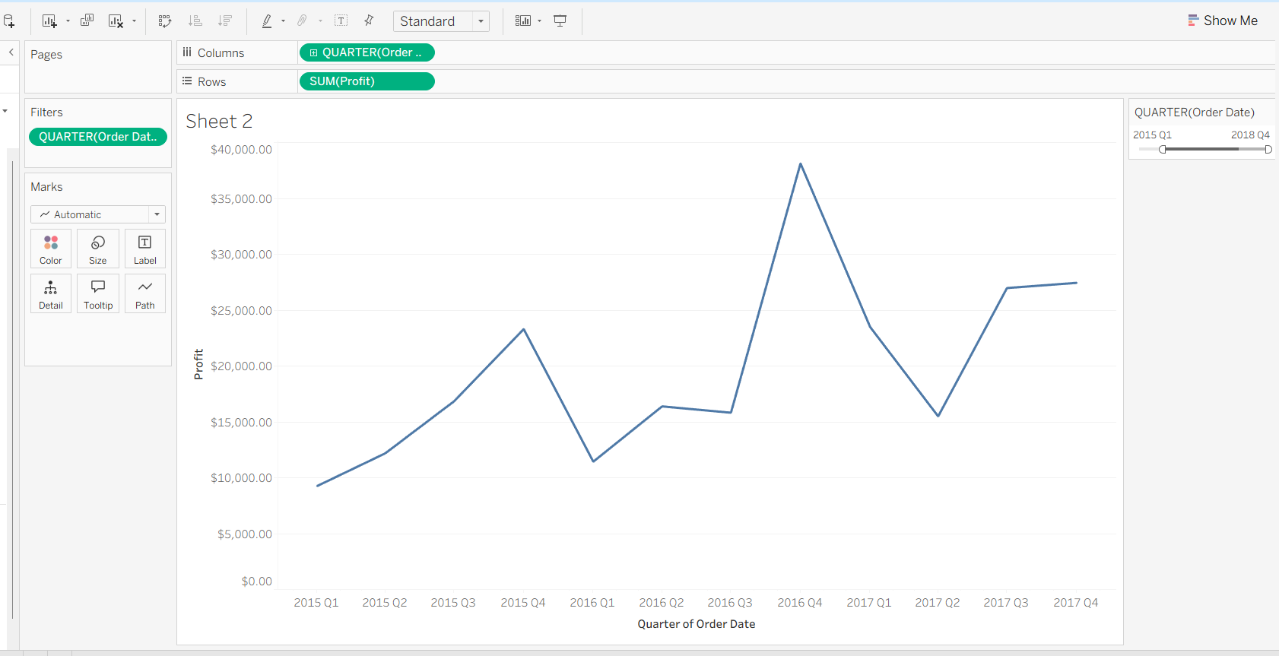

1. Showing data year wise easier to understand the trend over the years

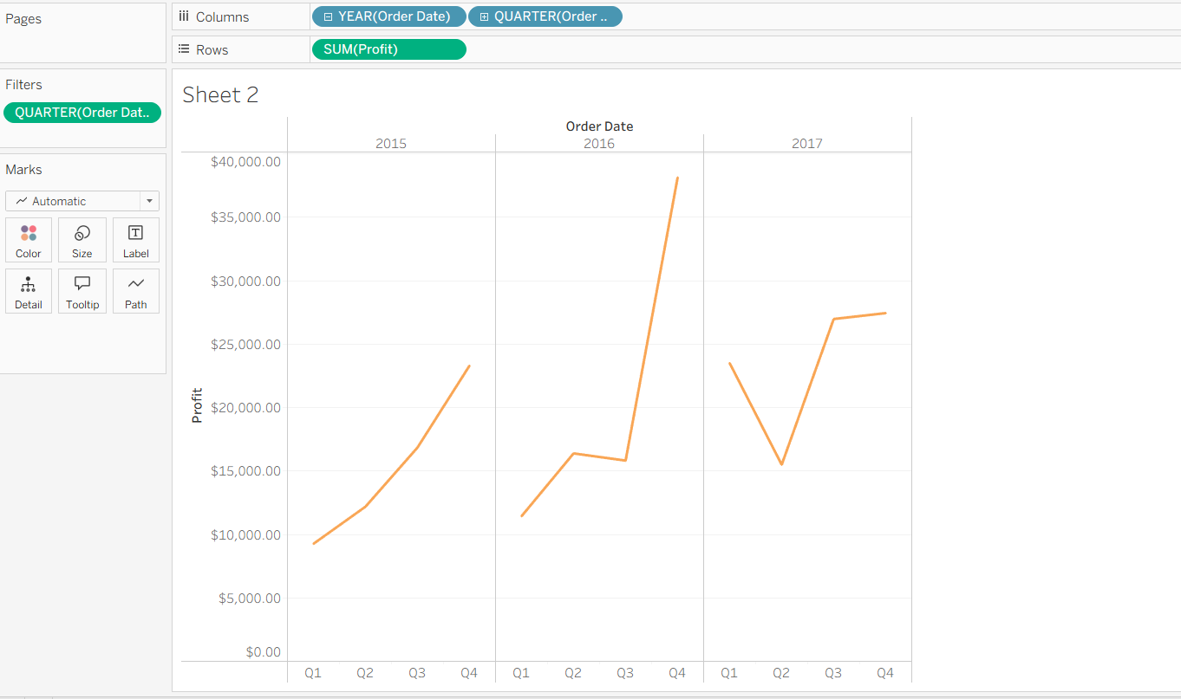

1. Below graph I showing the growth and the decline of sales over the years.

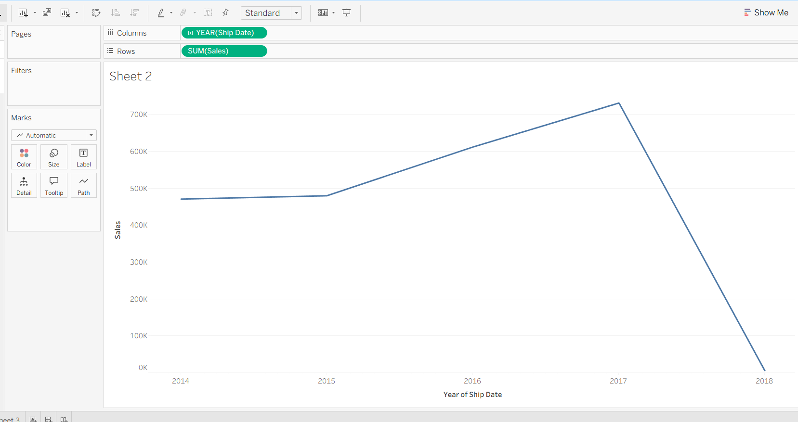

1. Below graph is showing the growth and the decline of Sales and profit simultaneously.

